**Haziq Brewery: Coffee Shop Sales**

**Situation**: You’re recently become franchise owner at **Haziq Brewery**, a coffee shop chain with three locations in New York City.

**Assignment**: To better understand purchase behaviour and streamline operations, you’ve collected transactional data from Jan-Jun 2023. **Your goal si to transform the data into a dynamic dashboard that franchise owners can use to identify patterns, trends and opportunities for the business.**

**Objectives**:

1. Profile and prepare the raw data for analysis.

* Take a moment for familiarize yourself with the data. How many transactions were recorded, over what period of time? What products and product categories were sold?
* Add a new column to calculate **Revenue**(price*quantity)
* Add new columns to calculate **Month** and **Day of Week** based on the transaction date (**Bonus**: display them as text (Jan, Feb, Mac, Sun, Mon), instead of numerical values)
* Add a new column to extract **Hour** from the transaction time

1. Explore the data with Excel PivotTables

* Insert a Pivot Table on a new tab to show **revenue** by **month**.
* Add two more Pivot Tables (on the same sheet) to show the **number of transactions** by day of week and by **hour of day**.
* Add a PivotTables(on same sheet) to show the **number of transactions** and **revenue** by **product type**, sorted descending and filtered to the top 15 (by transactions)

3.Build a dynamic dashboard to visualize patterns and trends.

* Add Pivot Charts to show revenue by month as a line chart, transaction by day of week andour of day as column charts, and transaction by product categoery as a bar chart.
* Aseemble the charts into a rough dashboard layout, and include space for the PivotTable showing TOP 15 product types( you can desin goyur own layout, or follow the solution)
* Add slicer for store location, and connect it to all of the PivotTables on the sheet
* Adjust formatting, alignment and polish to finalize the dashboard (TIP: hde the raw Pivot Tbales and remove the worksheet gridlines)
* Do you notice any interesting patterns or trends? What recommendations might you offer to improve Haziq Brewery operations?

Dashboard

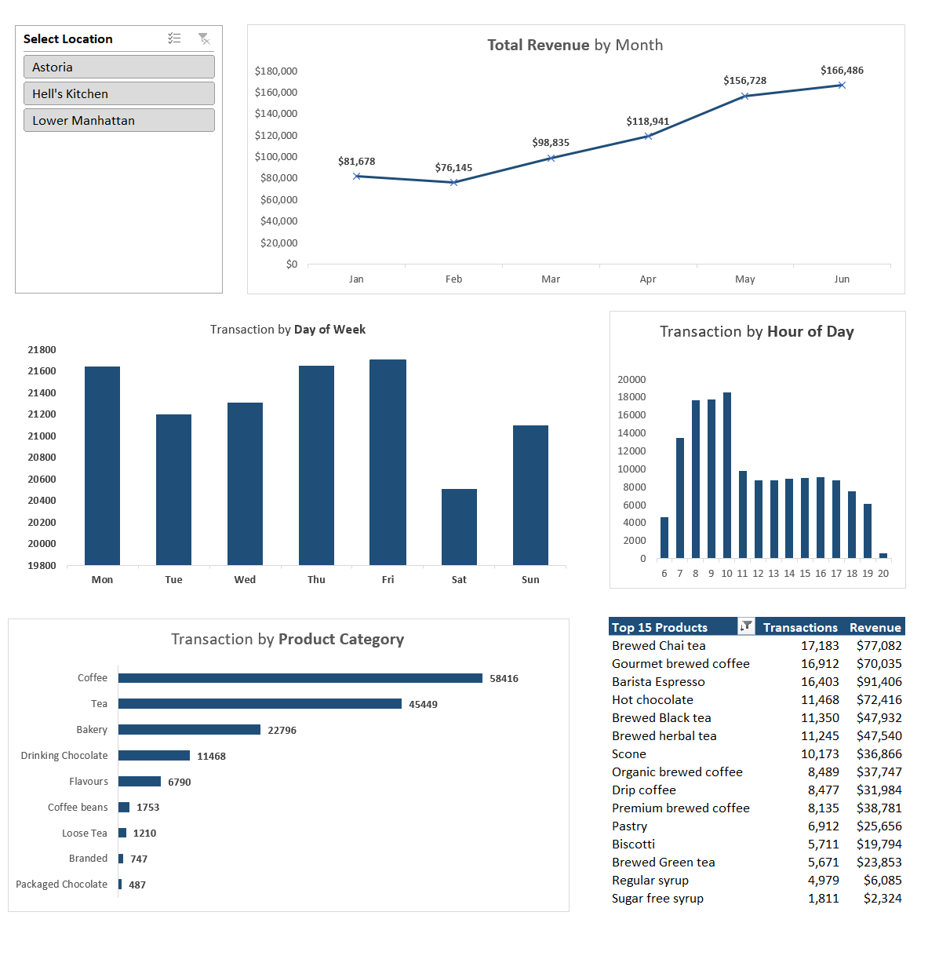

**Astoria**

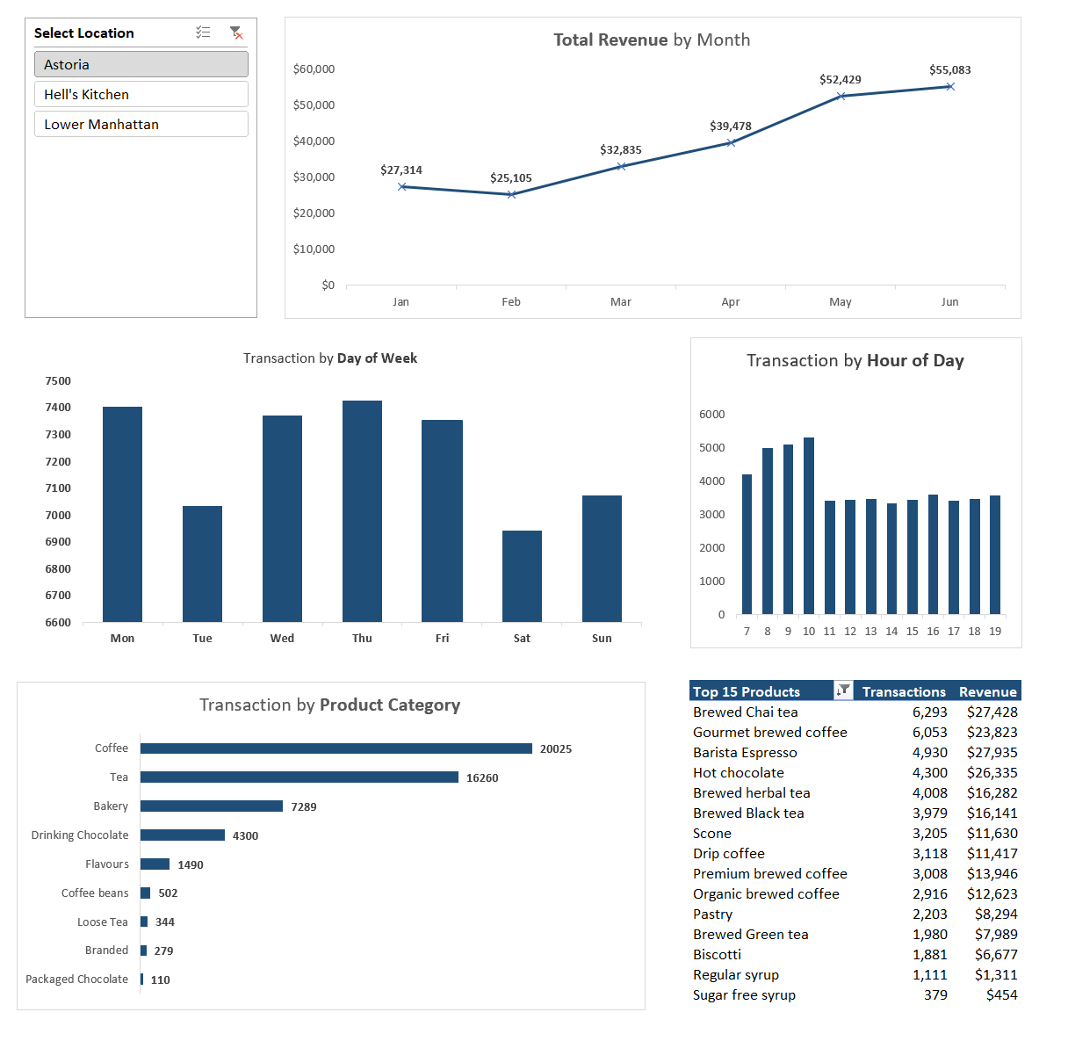

**1. Revenue Trends**

* **Monthly Growth:**
  + Revenue grows consistently from January ($27,314) to June ($55,083), with a significant increase from April to May.
  + Astoria shows slightly lower revenue figures compared to Hell's Kitchen but follows a similar upward trajectory.

**Opportunities:**

* **Consistency Across Months:**
  + Build on the strategies driving the May and June peaks. Focus on scaling these campaigns or products for the slower months, January and February.
* **Tailored Campaigns for Astoria:**
  + Understanding that Astoria's revenue lags behind Hell’s Kitchen slightly, consider location-specific promotions or product offerings to boost engagement.

**2. Transactions Analysis**

**Day of Week:**

* **Monday, Wednesday, and Thursday** dominate with the highest transactions (~7,400).
* **Tuesday** sees notably lower engagement (~6,900), similar to **Saturday**.

**Opportunities:**

* **Enhance Engagement on Tuesdays and Saturdays:**
  + Introduce specific campaigns to drive traffic on these days. Examples:
    - “Tea Tuesdays” with discounts on Tea or Tea-based drinks.
    - “Saturday Brunch Combos” to appeal to families and weekend shoppers.
* **Maximize Busy Days:**
  + Leverage Monday, Wednesday, and Thursday traffic to upsell products or promote underperforming categories.

**Hour of Day:**

* Peak morning traffic (9 AM to 12 PM) is evident but slightly lower compared to Hell’s Kitchen.

**Opportunities:**

* **Drive Afternoon Engagement:**
  + Offer afternoon promotions targeting 1 PM to 4 PM, such as “Afternoon Coffee Specials” or “Pastry + Hot Chocolate” bundles.
* **Morning Rush Optimization:**
  + Ensure efficient service during peak hours to maximize throughput.

**3. Product Categories**

* **Key Insights:**
  + Coffee dominates with 20,025 transactions, followed by Tea (16,260) and Bakery (7,289).
  + Drinking Chocolate shows notable strength (4,300 transactions), outperforming some smaller categories like Flavours and Coffee Beans.

**Opportunities:**

* **Upsell with Bakery and Drinking Chocolate:**
  + Pair these with Coffee and Tea for bundled offers.
  + Promote Drinking Chocolate as a premium product or a seasonal treat.
* **Focus on Smaller Categories:**
  + Highlight Flavours (1,490 transactions) and Coffee Beans (502) through targeted marketing. For example:
    - Emphasize Coffee Beans for at-home brewing customers.
    - Introduce new uses for Flavours (e.g., recipes, add-ons).

**4. Top 15 Products**

* **Top Performers:**
  + "Brewed Chai Tea" leads in revenue ($27,428), followed closely by "Hot Chocolate" ($26,335) and "Barista Espresso" ($27,935).
  + Biscotti and Regular Syrup have lower transaction volumes and revenues.

**Opportunities:**

* **Reinforce Popular Products:**
  + Promote top sellers like "Brewed Chai Tea" and "Barista Espresso" as signature drinks for Astoria.
* **Boost Lower-Performing Items:**
  + Run campaigns to promote lesser-performing items like Regular Syrup and Biscotti.
  + Bundle lower performers with top sellers to increase visibility and sales.

**Comparing Astoria to Hell’s Kitchen and Lower Manhattan**

* **Revenue:**
  + Hell’s Kitchen has slightly higher revenues compared to Astoria, indicating potential untapped opportunities in Astoria.
* **Day Trends:**
  + While Hell’s Kitchen shows Tuesday and Friday as peak days, Astoria’s busy days are Monday, Wednesday, and Thursday. Promotions should reflect these unique patterns.
* **Product Preferences:**
  + Drinking Chocolate is relatively stronger in Astoria than in other locations, suggesting an opportunity to further differentiate the product lineup.

**Recommendations for Astoria**

1. **Campaigns to Drive Traffic on Low Days:**
   * Use promotions like “Tea Tuesday” or “Saturday Coffee Combos” to address underperforming days.
2. **Enhance Off-Peak Hours:**
   * Introduce discounts or loyalty points for transactions made during slower afternoon hours.
3. **Capitalize on Product Strengths:**
   * Expand on the popularity of Drinking Chocolate and Chai Tea with seasonal or premium offerings.
4. **Boost Underperforming Categories:**
   * Focus marketing on Flavours and Coffee Beans, targeting niche customer segments like homebrewers.
5. **Tailor for Location-Specific Needs:**
   * Use localized promotions to close the gap in revenue between Astoria and Hell’s Kitchen.

**Hell’s Kitchen**

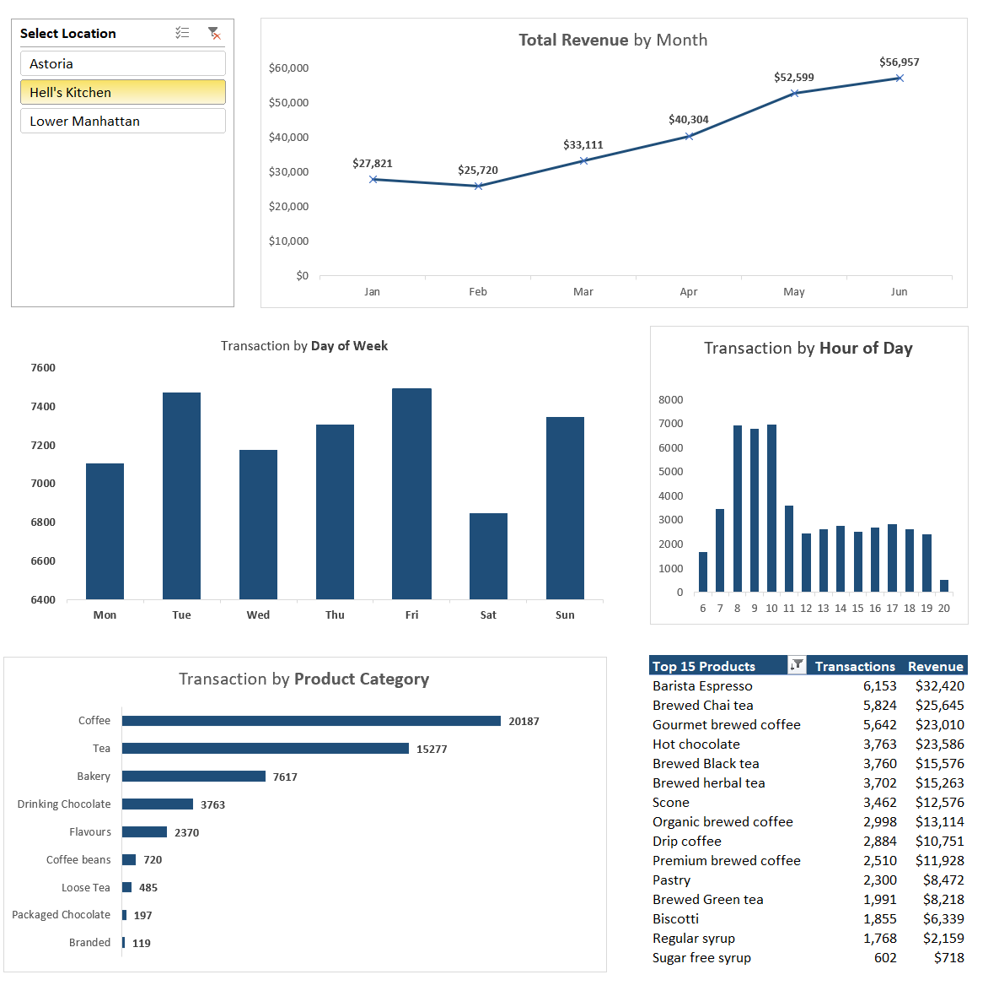

**1. Revenue Trends**

* **Monthly Growth:**
  + Revenue grows steadily from January ($27,821) to June ($56,957).
  + A significant increase is seen between April ($40,304) and May ($52,599), consistent with the previous analysis.

**Opportunities:**

* Similar to the previous dataset, the focus should be on leveraging the peak months (May and June) for maximum impact and addressing the slow months (January and February) with promotions or campaigns tailored to winter preferences.

**2. Transactions Analysis**

**Day of Week:**

* The trend is slightly different from the prior dataset:
  + **Tuesday** and **Friday** have the highest transaction volumes (~7,600), followed closely by **Sunday** (~7,400).
  + **Saturday** has the lowest transaction count (~6,500).

**Opportunities:**

* **Capitalize on Busy Days:**
  + Reinforce Tuesday and Friday traffic with loyalty offers or upselling strategies to boost average transaction value.
* **Increase Saturday Traffic:**
  + Introduce weekend specials or family-focused bundles to encourage purchases on Saturdays.
  + Create “Saturday Brunch” promotions with popular items like Barista Espresso or Bakery products.

**Hour of Day:**

* The morning peak (9 AM - 12 PM) remains prominent, with a gradual decline after 1 PM.

**Opportunities:**

* **Boost Afternoon Sales:**
  + Target afternoon customers with limited-time discounts or deals like “Afternoon Tea + Scone” bundles.
  + Introduce smaller, grab-and-go snack pairings to attract casual shoppers.

**3. Product Categories**

* **Dominance of Coffee and Tea:**
  + Coffee remains the leader with 20,187 transactions, followed by Tea at 15,277.
  + Bakery ranks third (7,617), with smaller contributions from Drinking Chocolate and Flavours.

**Opportunities:**

* **Maximize Coffee & Tea:**
  + Promote premium Coffee and Tea options (e.g., upselling specialty brews or premium herbal teas).
  + Offer subscription models for regular customers focused on these two categories.
* **Cross-Sell Bakery Items:**
  + Leverage Bakery items to complement Coffee and Tea purchases. For instance:
    - Pair hot drinks with Scones, Pastries, or Biscotti for bundled deals.
* **Promote Underperforming Categories:**
  + Drinking Chocolate and Flavours could benefit from seasonal positioning (e.g., winter hot chocolate promotions or summer syrup-based iced beverages).
  + Encourage packaged goods like Loose Tea and Packaged Chocolate as gifts or takeaway options.

**4. Top 15 Products**

* **Best Performers:**
  + “Barista Espresso” (6,153 transactions, $32,420) remains the top product.
  + High revenue contributors include “Brewed Chai Tea” ($25,645) and “Hot Chocolate” ($23,586).
* **Lower Performers:**
  + Products like “Sugar-Free Syrup” and “Regular Syrup” have minimal transactions and revenue.

**Opportunities:**

* **Focus on Popular Products:**
  + Create targeted campaigns featuring the top products, highlighting them as customer favorites.
  + Use these products in cross-promotion or as part of loyalty rewards programs.
* **Increase Awareness for Lower-Ranked Products:**
  + Run educational or health-focused campaigns for items like “Sugar-Free Syrup,” appealing to diet-conscious customers.
  + Bundle these items with higher-performing drinks to increase visibility.

**Comparing Locations**

If this dataset represents a comparison across locations (Hell’s Kitchen vs. others):

* Hell’s Kitchen shows slightly higher transactions for peak days (Tuesday and Friday vs. Monday in the previous data).
* Sunday sees stronger performance here compared to other locations, indicating customer habits may vary by area.
* These insights can inform **location-specific strategies**, such as tailoring deals or promotions based on local trends.

**Conclusion & Recommendations**

1. **Revenue Growth Strategies:**
   * Replicate successful campaigns from May and June in other months.
   * Tailor offerings during slower months (January and February) to maintain momentum.
2. **Optimize Transactions by Day:**
   * Reinforce busy days (Tuesday, Friday) with targeted offers.
   * Address weaker days (Saturday) with weekend-focused deals.
3. **Product Strategy:**
   * Prioritize Coffee and Tea as anchor products while cross-selling Bakery and smaller categories.
   * Promote underperforming items through bundling or seasonal campaigns.
4. **Afternoon Sales Growth:**
   * Launch “Afternoon Tea” promotions or snack pairings to counter the post-1 PM dip.

**Lower Manhattan**

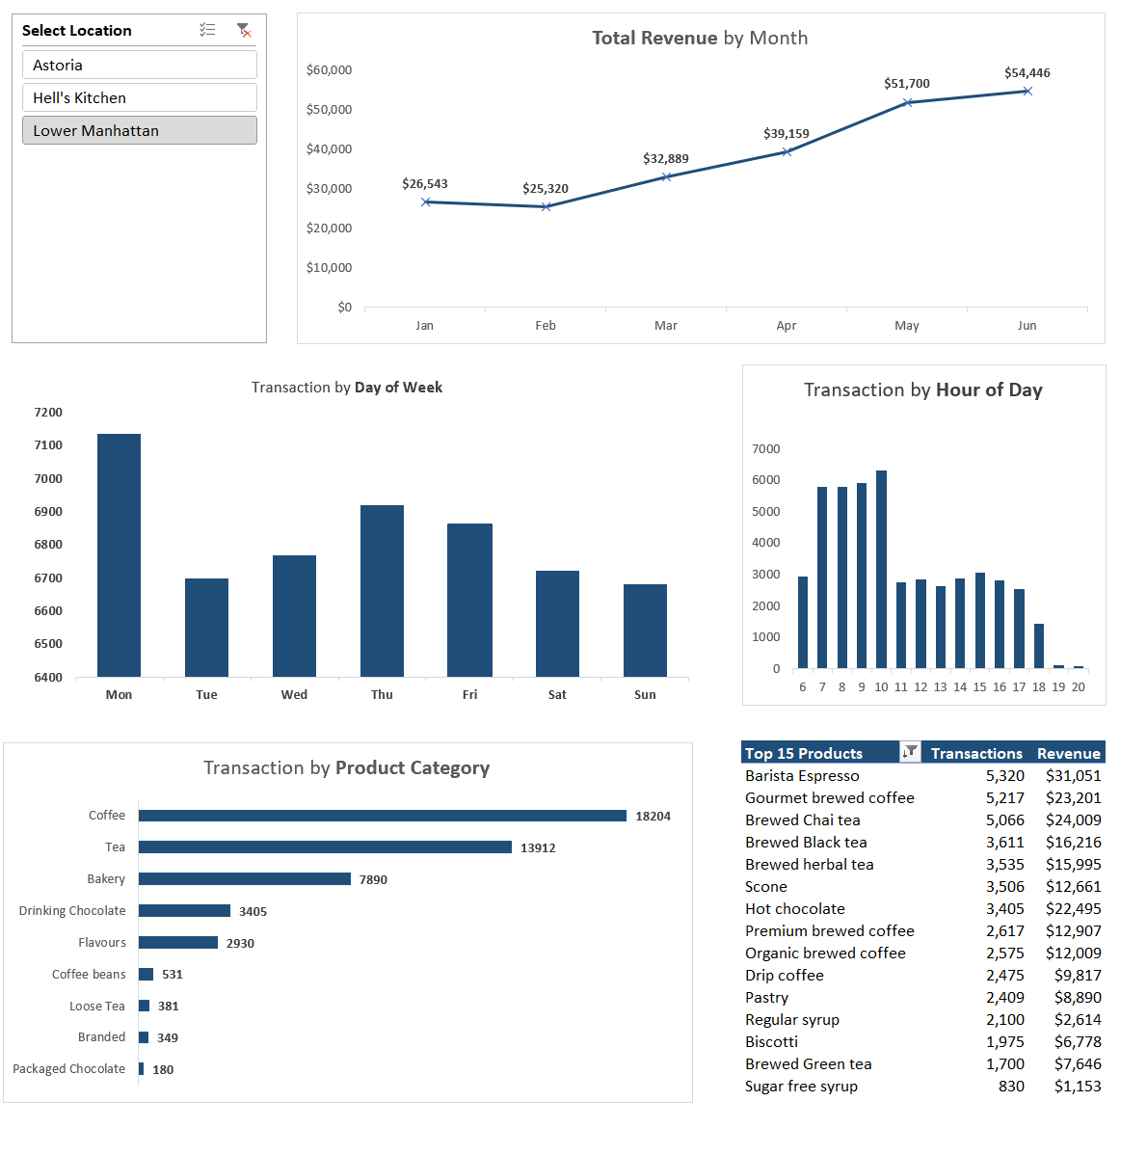

**1. Revenue Trends**

**Key Observation:**

* The steady increase in revenue month-over-month indicates healthy growth, likely driven by seasonal factors, effective marketing, or customer retention.

**Opportunities:**

* **Identify Growth Drivers:** Analyze what’s driving the jump from April to May (e.g., seasonal beverages, new product launches, or marketing campaigns). Replicate these strategies in future months.
* **Seasonal Planning:** Since revenue peaks in May and June, plan for these months with increased stock, staffing, and targeted promotions.
* **Address Slow Months:** Revenue in January and February is significantly lower. Introduce winter specials, loyalty rewards, or discounts to boost sales during these periods.

**2. Transactions Analysis**

**Day of Week:**

* Monday outperforms other days with ~7,200 transactions, while weekends see lower engagement.

**Opportunities:**

* Monday Promotions: Build on the high engagement by offering Monday-exclusive deals or “start-of-the-week specials” to reinforce customer habits.
* Weekend Campaigns: Use creative campaigns to increase weekend activity, such as “Weekend Coffee Bundles” or family-friendly bakery promotions.

**Hour of Day:**

* Morning hours (9 AM - 12 PM) are the busiest, showing strong alignment with morning coffee habits.
* Afternoon transactions drop significantly after 2 PM.

**Opportunities:**

* Morning Rush Optimization: Introduce fast service options during peak hours (e.g., pre-order apps or express lines).
* Afternoon Boosters: Experiment with discounts, happy hour pricing, or combo deals (e.g., “Tea + Pastry” or “Afternoon Espresso”) to incentivize purchases between 2-5 PM.

**3. Product Categories**

**Key Insights:**

* Coffee (18,204 transactions) and Tea (13,912 transactions) dominate.
* Smaller categories like Flavours, Coffee Beans, and Packaged Chocolate contribute far less.

**Opportunities:**

* **Upsell & Cross-Sell:**
  + **Pair high-performing Coffee and Tea with smaller categories. For example:** 
    - Promote Coffee with Flavoured Syrups or Bakery items.
    - Suggest Chocolate or Tea add-ons during checkout.
  + **Offer bundles like “Latte + Biscotti” or “Green Tea + Flavoured Syrup.”**
* **Expand Underperforming Categories:**
  + Flavours and Packaged Chocolates could benefit from better positioning (e.g., impulse buys near checkout counters).
  + Market Coffee Beans and Loose Tea to home-brewing customers, emphasizing freshness and quality.
* **Promote Seasonal Variants:**
  + Introduce limited-time flavours or festive teas to drive excitement and novelty.

**4. Top 15 Products**

**Key Insights:**

* "Barista Espresso" (5,320 transactions, $31,051 revenue) is the best seller, outperforming other products significantly.
* Lower-ranked items like "Sugar-free Syrup" have fewer transactions and low revenue.

**Opportunities:**

* **Focus on Bestsellers:**
  + Maintain stock and consistent quality for top performers like "Barista Espresso" and "Gourmet Brewed Coffee."
  + Highlight them in marketing campaigns as customer favorites or “best value” options.
* **Promote Lesser-Known Products:**
  + Run campaigns highlighting the benefits of underperforming items like “Sugar-free Syrup” (e.g., health-conscious advertising).
  + Bundle smaller items with top products to drive sales (e.g., “Espresso + Sugar-free Syrup for $X”).
* **Seasonal Specials:**
  + Use insights to introduce limited-time offers for bestselling categories (e.g., flavored espressos or chai lattes during the holidays).

**Actionable Steps**

**Short-Term:**

1. Run “Monday Morning Rush” campaigns to leverage peak day and time.
2. Bundle high-performing and low-performing products to increase transaction value.
3. Offer time-specific deals (e.g., afternoon happy hours) to drive off-peak sales.

**Long-Term:**

1. Invest in promoting smaller categories like Flavours and Packaged Chocolate through better positioning and campaigns.
2. Use customer insights to develop products or flavors tailored to trends (e.g., seasonal beverages).
3. Explore loyalty programs or subscription models for recurring purchases of Coffee and Tea.

**Data Opportunities:**

1. Analysed customer segmentation further to tailor promotions (e.g., frequent vs. occasional buyers).
2. Track customer preferences by location to customize strategies for Astoria, Hell’s Kitchen, and Lower Manhattan.